Mini Project followed steps:
- Data Cleaning in Excel: (Sheet1) below steps
- In Name column changed the column to Proper format and remove the Surname using proper function to change the valid format.
- Gender Column using Proper function to change the data to valid format.
- Age Imputation using Numerical Imputation formulae to fill blanks as overall average value.
- Age level column using IF formulae to transform the data to category wise.
- Experience Imputation using Numerical Imputation formulae to fill blanks as overall average value.
- Hourly Rate Imputation using Numerical Imputation formulae to fill blanks as overall average value.
- Is Active Imputation using Categorical Imputation formulae to fill blanks as Unknown.
- Hourly Rate column changed the data format to standardized Currency format.
- Client Satisfaction Imputation using Numerical Imputation formulae to fill blanks as overall average value.
- I have created the table for show the difference before blank and after blank.
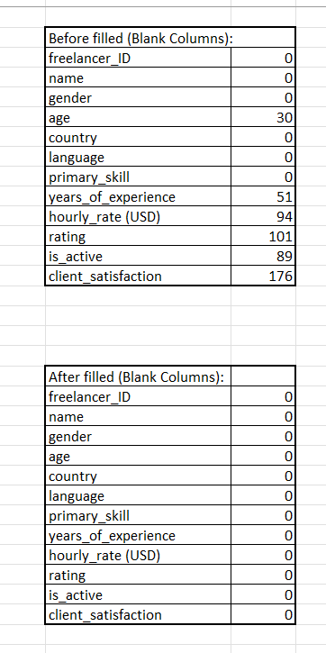
11.I was created Cleaned data sheet and using vlook up based on the freelancer ID to filled up the cleaned data in Cleaned sheet.

- Data Transformation and Visualization in POWER BI:
- Data Transformation:
- I was created one column named as Age Category for visualize the age data to categorical wise as “Young Adults, Adults, Middel – Aged Adults, Older Adults”.
- I was created one column named as Rate Category for visualize the Per hour rate data to categorical wise as “Basic Level, Mid-Level, High Adults”.
- I was created one column named as Rating Category for visualize the Rating data to categorical wise as “Bad Rating, Fair Rating, Good Rating, Excellent Rating”.
- I was created one column named as Client Satisfaction Category for visualize the Client Satisfaction data to categorical wise as “Fair, Good, Very Good, Excellent”.
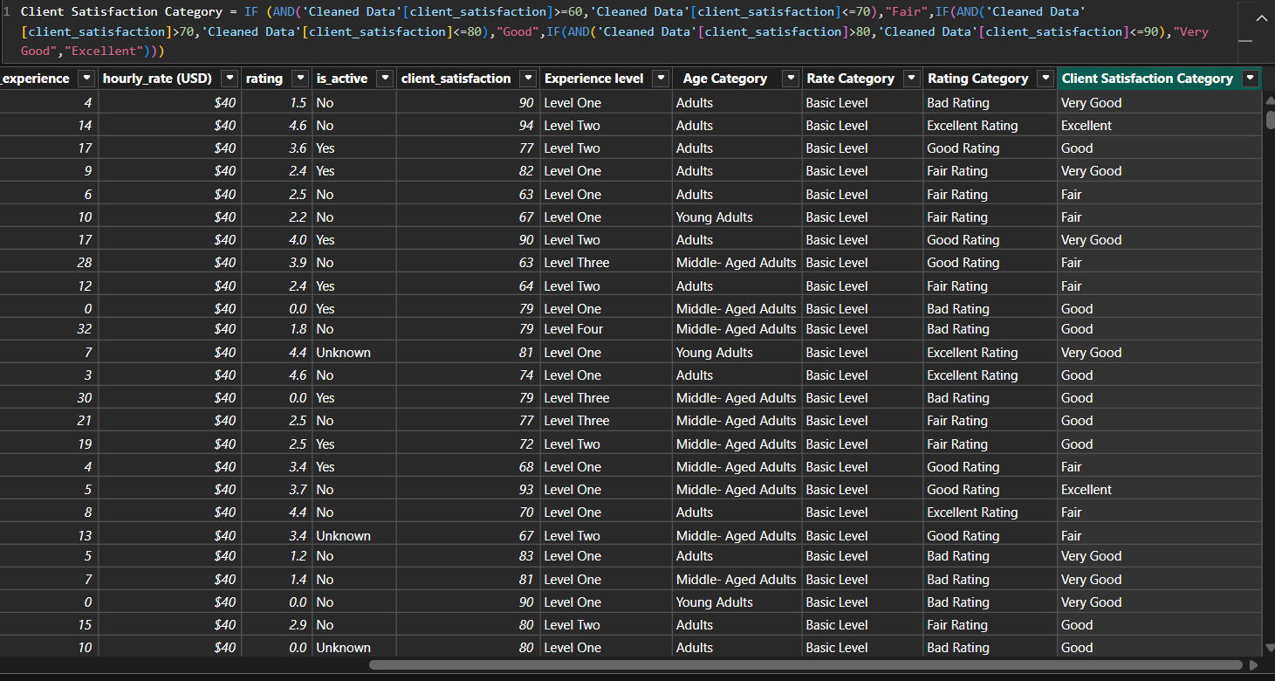
Measures:
1.Country Count
2.IS Active Count
3.Skills Count.
4.Total Freelancers Count.
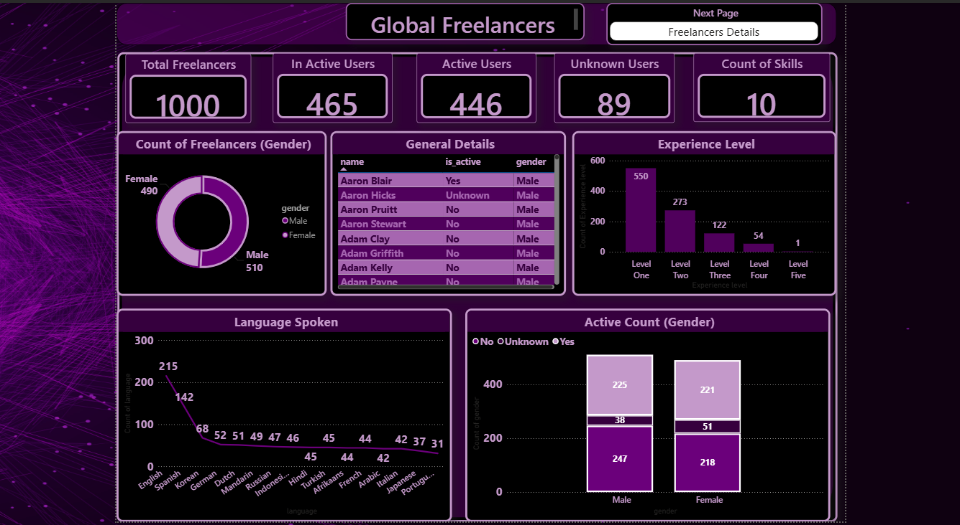
Data Visualizations Steps: (Global Freelancers)
- Created Four Cards for visualize count for Total Freelancers, In Active Users, Active Users, Unknown Users, Count of Skills.
- In Doughnut chart to visualize the Count of Freelancers differentiate by Gender.
- General Details chart to visualize the Name, Is Active, Gender of the Freelancers.
- Bar Chart to visualize the Experience level count.
- Line chart to visualize the freelancer Language spoken Count.
- Active Count (Gender) Bar chart to visualize the Gender and categorize the Active count.

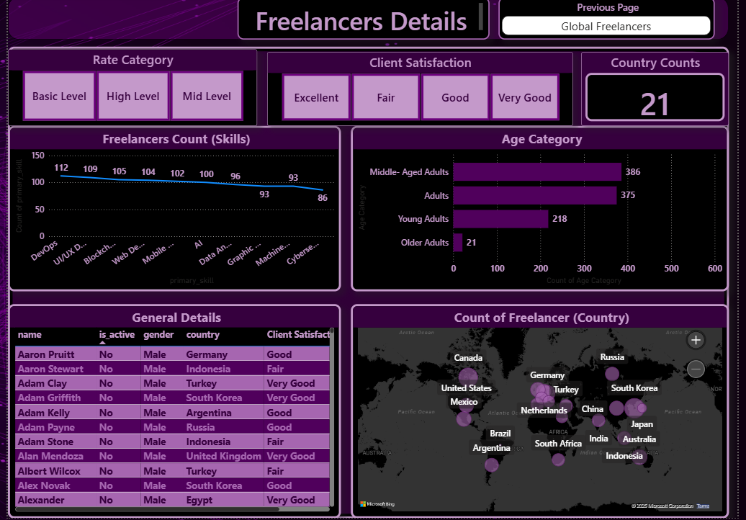
Data Visualizations Steps: (Freelancers Details)
- I have created three Slicers for “Rate Category, Client Satisfaction”
- Created card to show Total no of Country.
- In Line chart to show casing the Count of Free lancers skills.
- Clustered bar chart to show the count of Age Category.
- In General Details table showcasing the “Name, Is Active, Gender, Country, client Satisfaction”.
- In Map Chart to Visualize the count of Freelancers in Country wise.

